HS2 Review:
Frequent, fast, joined-up links for the Northern Powerhouse and the Midlands

An assessment for Crewe Town Council, 11th September 2019

Contents
Background 1
Four priority elements 2
Economic growth centres 2
Designation of main hubs 6
New express inter-regional rail services 7
Crewe as the conduit 10
Better local and regional services, and freight gains 12
Annex with HS2 Review terms of reference 17

Background

- The Secretary of State for Transport on 21st August 2019 announced a fundamental review of the HS2 project. The Government was dissatisfied with HS2 project progress and costings, and with uncertain benefits and opening dates.

- A major re-assessment has been started, summarised below, and the terms of reference are in an annex. The review is required to report to Government this Autumn.

- In parallel, and both as a check and as a contribution to the main review, two other non-Governmental reviews have begun: by the Northern Powerhouse, and by the former NW MP and Chancellor, George Osborne.

- Many regions and communities have looked during recent years for HS2 to achieve real results in re-balancing the English economy, allied to Government statements offering much more input and priority north of London.

- So the HS2 Review offers a key opportunity to restate and clarify the real benefits that CAN be achieved – if there is a revitalised rail network in the North and the Midlands leading to fundamentally greater outcomes.

- The North and Midlands can achieve their aims, providing that a reviewed HS2 can be properly integrated with existing travel corridors, in timescale, rail network planning, and service development and benefits.

- So this assessment looks as the present gaps in connectivity and related economic shortcomings, and how those gaps can best be closed and great results obtained.

- Much of the railway geography in the North West and for longer distance corridors to the Midlands and the South is channelled via Crewe, for passenger and freight services, and as currently foreseen for HS2. Getting Crewe fit for purpose for the next half-century is vital.

- The railway potential should be understood with full awareness of the scope and need for greater connectivity within the North West, and further to North Wales, the West and East Midlands, and to Scotland, not just for better London trains.

- Crewe’s signalling and trackage already needs renewal in the 2020s with large scale expenditure, so it is best for the whole of the investment to be defined and made with future HS2 and expanded classic services fully in mind, and also with better freight capabilities, so that money does not have to be spent twice over.

Four priority elements

- The railway potential has to be seen in a wide context – it is about the economic and social gains that can be enabled through key catchments and via important transport hubs, not just about railway capabilities and realistic timescales and costs.

- There are four elements which interlock and together make a coherent plan for the North West and the Midlands and take full advantage of a reviewed HS2:

  - Economic growth to be centred on hub-and-spoke networks radiating from designated interchanges, maximising accessibility and connectivity across the regions.

  - Designation of main hubs including Crewe, for the reviewed HS2 and improved classic rail network north of Birmingham.

  - New express inter-regional rail services to lift rail market share and environmental capacity between city centres and main hubs in the North West, West Midlands and East Midlands.

  - Identify opportunities for new and improved local and regional passenger services, and freight operations, arising from capacity released on existing lines.

Economic growth centres

- To underpin economic growth objectives, transport infrastructure should be matched in location, capability and in timescale with existing and intended investments by public authorities and private stakeholders.

- Major conurbations have already demonstrated that a high connectivity passenger rail network with interlinking corridors and multiple ‘hubs and spokes’, makes a strong base for households to improve their economic opportunities: to have multiple choices of jobs and workplace without having to move home. This also responds to the modern tendency for clustering of large scale centres of employment, and changes of employer.

- Crewe is a principal shire town with industrial and educational strengths, at the heart of local and national railway corridors. It has the ability to develop these connectivity principles for its more varied hinterland, once a revised HS2 (essentially, express railway capacity improvements) is integrated with the existing rail lines, and an effective hub-and-spoke network is developed to serve the surrounding 20-25 miles. A reinvigorated railway network will be the right stimulus for local and regional expansion in the catchment.

  - Crewe is situated within the Borough of Cheshire East which is a relatively prosperous part of the country. Crewe itself is well situated with 360 degree communications to the rest of Britain, and with thriving advanced manufacturing industry (e.g. Bentley Motors).

  - However, thirteen of Crewe’s 47 Lower Super Output areas (LSOAs – a small geographical area used for statistical purposes) are amongst the 20% most deprived in England. Health outcomes, educational attainment, poverty and crime statistics are all significantly worse than average.

  - The town needs physical, economic and social regeneration, and rail network investment is seen as the catalyst for this. The Masterplan Vision and the Area Action Plan both propose a comprehensive set of actions, including for example developing the skills of the local population to enable them to benefit from the new opportunities.

- Regionally, the ‘Constellation Partnership’ consists of 7 local authorities and 2 LEPs including the towns of Crewe, Stafford and Stoke-on-Trent, so crosses the divide between the North West region and the West Midlands region. It has a population of 1.3m.

- The Constellation Partnership HS2 Growth Strategy (Nov 2018) will, dependent on a minimum service of 5/7 HS trains per hour in each direction at Crewe, and 2 HS trains per hour in each direction at Stoke and Stafford, deliver by 2040:
- 120,000 additional full time jobs
- 100,000 additional homes, increasing the population from 1.3m to 1.525m
- £6bn increased contribution to the national GVA of which £3bn will be directly generated by a full specification HS2 service and complementary growth strategy.
- In Crewe alone, this will mean 7,150 additional homes and 37,000 extra full time jobs, set out in Crewe Masterplan Vision 2017.

- This will in part be delivered by a new commercial hub centred around Crewe Station. An Action Plan is currently out to consultation which will provide c. 350,000 sq.m of new, high quality employment/economic floorspace enabling some 26,000 jobs and up to 3,700 homes in the immediate vicinity of Crewe HS2 Hub Station (Crewe Hub Action Area Plan).

- So it is important for there to be a decently modern transport network covering main corridors and travel flows, which is comprehensive and offers dependable travel throughout a region, integrated with local buses. This should also embrace neighbouring regions where large centres are no further in travel time, including Stoke-on-Trent and Stafford.

- In Crewe’s case, analysis by JRC consultancy in 2016-17 showed that within a maximum one hour local connection and travelling time, the range of accessibility across a 25 mile catchment varied considerably, depending on service frequencies and connection times between trains at Crewe hub.

- A good frequency allowed access much further within the hinterland, and helped to reinforce the case for some new local trains and stations, made possible by new fast tracks releasing capacity on existing main lines. In turn this would strengthen the scope for economic growth across the catchment.

- The mapping below shows the difference in Crewe catchment accessibility, based first on a 2 tph HS service, and then 4 tph:-

Map 1: Crewe with 25 mile rural catchment circle, showing the limitations of effective catchment with low frequency services:

Crewe with a 2 tph HS service incurs 15 minute average wait plus a small interchange walking time, but perception penalties (x2½) raise this to 45 minutes, with only 15 minutes left for effective public transport time for a connecting journey. Potential rail connections within that limitation are shown, with possible new stations and services shown in black. As a different measurement, car times within nominal one hour at urban 12 mph (pink) and rural 30 mph (green) average speeds are also shown in outline, allowing for perceived access time to a car. These ignore the minimum connecting times, and assume arrival at Crewe a ‘safe’ time before a train departs.
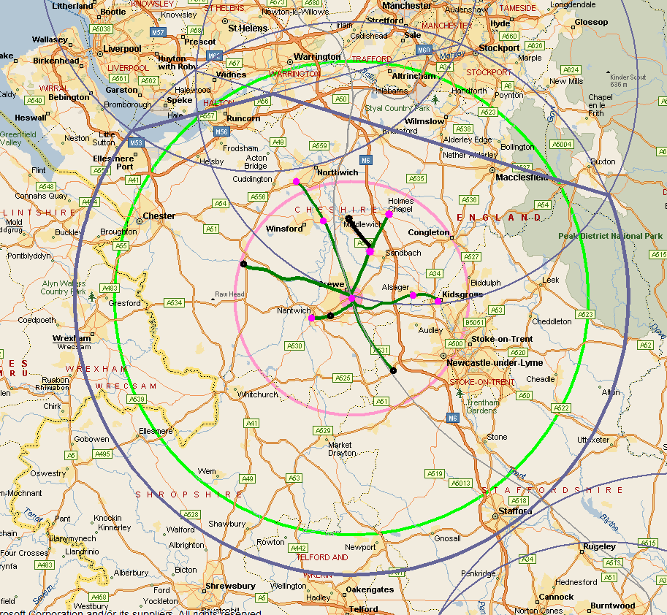

Map 2: Crewe with 25 mile rural catchment, showing the public transport catchment with high frequency HS services (at least 4 tph, = 20 minutes more access time):

The fundamental difference in effective public transport catchment with higher frequency services – and therefore effective benefits – is evident.

Adopting a 4 tph HS service at Crewe would reduce the walking and waiting element to roundly 10 minutes actual, 25 perceived, so there are then 35 minutes to make a useful public transport journey within the Hub catchment, before going over a perceived hour in total. Potential rail connections within that time period are shown, with possible new stations and services shown in black. Urban and rural onwards car access times from those further railheads are also illustrated, limited to a maximum 1 hour total travel, walking and waiting time from an HS train. Some localised (pink) walking times for catchment stations are also shown, within 1 hour.
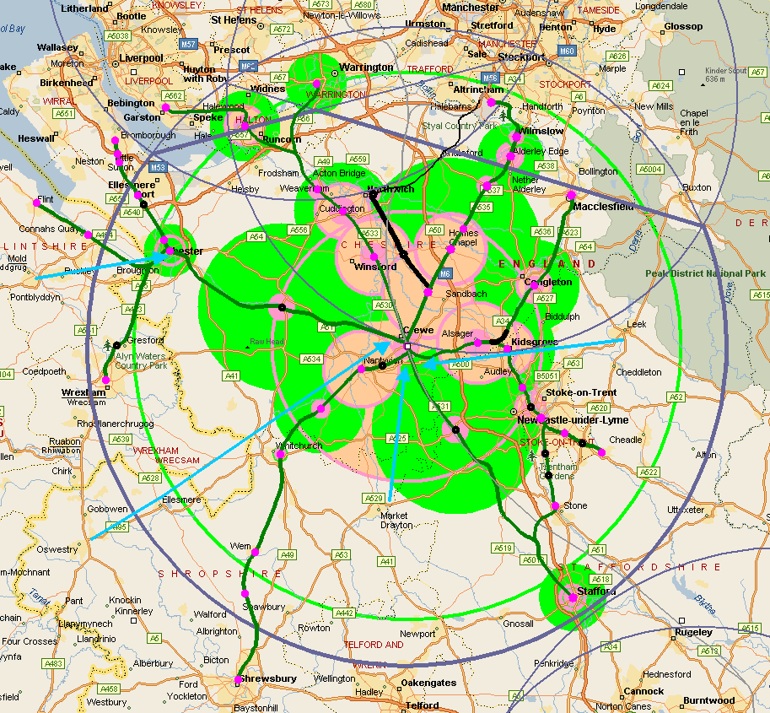

Possible new rail accesses include up to 10 additional local stations including rural and Stoke area stops, more frequent services, and new links to Middlewich and Northwich, and to Congleton and Macclesfield.

Designation of main hubs

- The same principle of a decently modern transport network allied to economic growth hub-and-spoke capabilities can be adopted on a larger scale. Crewe is already designated as an HS2 hub and major interchange. Other major 20-25 miles hub-and-spoke locations are illustrated in the map below, along with smaller hubs with 10 mile catchments, for Northern Powerhouse and the East and West Midlands north of Birmingham.

- A dense volume of hubs and potential connectivity is shown with this matrix. It is expected that the Northern Powerhouse and Midlands Connect will advise in defining the required transport networks which will underpin the hubs.

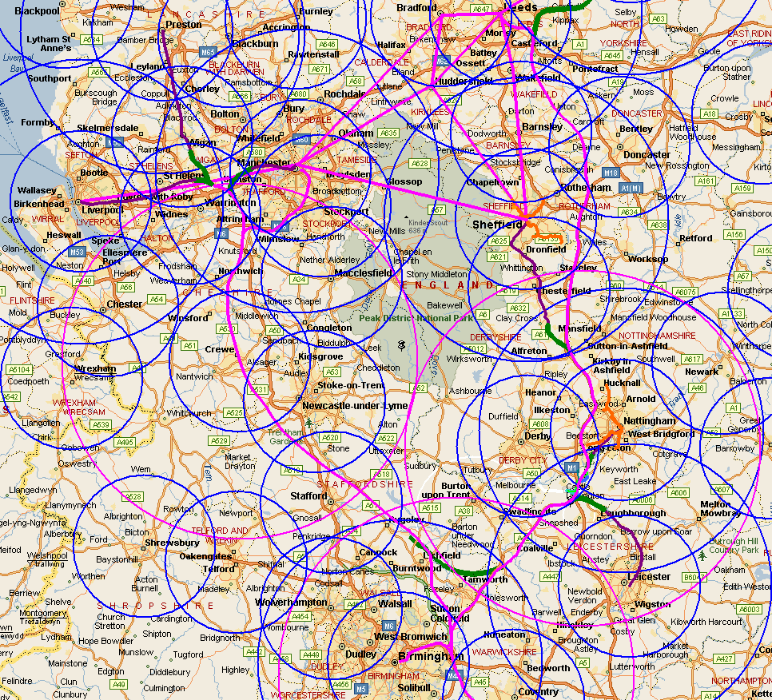
The map above shows HS2 routes as currently conceived, improved Northern Powerhouse links (diagrammatic), and scope for some inter-regional HS or equivalent linkages, eg, to link the East Midlands to the Northern Powerhouse via an East Midlands-HS2 Phase 2A chord, spurs towards Nottingham and Leicester, and towards Liverpool and Manchester Victoria (the latter for north-of-Manchester and West Yorkshire access). This illustrates that the present HS2 scheme underplays linkages and benefits that are possible with a new look at gaps in network connectivity.

New express inter-regional rail services

- These are intended to lift rail market share and environmental travel capacity between city centres and main hubs in the North, West Midlands and East Midlands.

- The strategic transport issue is that inter-urban main road corridors linking main city regions face pressures of capacity, congestion and journey variability, as identified by Highways England: with M6 travelling conditions replicated on more roads unless something is done.
The situation is shown in examples from this Highways Agency ‘underpinning’ document: Socio-economic_analysis_future_forecasts_and_the_SRN.pdf, where mapping below highlights the main Northern and Midlands areas in terms of employment and population density, annual road network delay hours, and baseline forecast change in employment to 2030. The combination of the North, West Midlands and East Midlands is a core part of economic and traffic priorities.

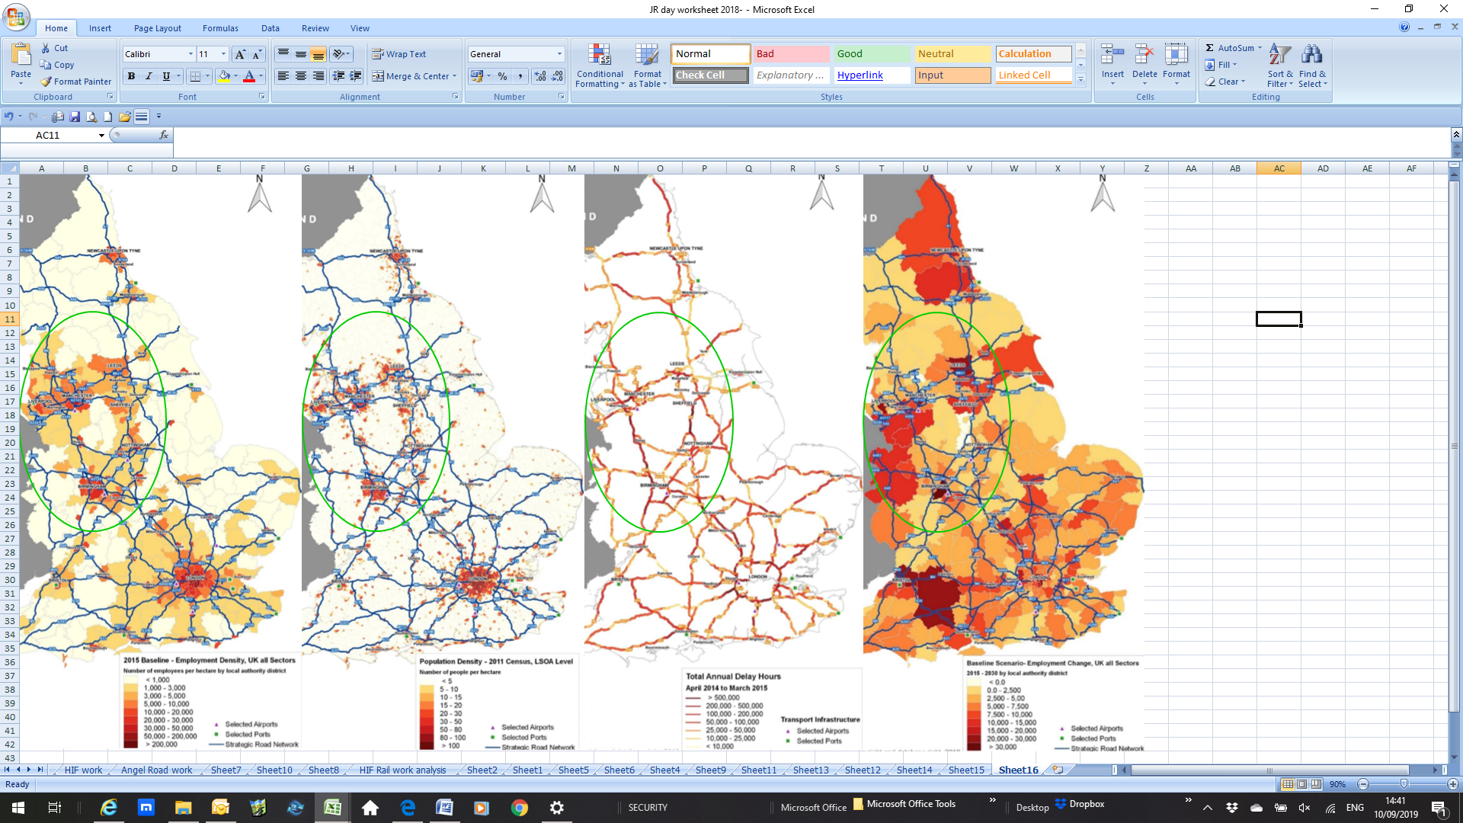

- Meanwhile existing rail has a variable market share on inter-urban routes in the North and Midlands. Where travel times and frequencies are good, rail can be attractive, but where not, it is weak, hindered by junction and capacity limitations on rail corridors little improved since Beeching, with slow door-to-door times and low frequencies.

- Assessed actual flows are low for inter-regional rail travel, as shown in the attached ORR table for 2017-18 volumes (below). For example a nominal 5 million passengers a year, divided by a nominal 300 days to suggest a weekday flow, and by perhaps 17 hours per day, would give an average hourly rail flow to/from another region of roundly 1,000 passengers. This would be the equivalent of just one lane of road traffic per hour, so rail overall isn’t doing a great job between many English regions.

- Inter-regional rail usage table from ORR data: https://dataportal.orr.gov.uk/statistics/usage/regional-rail-usage/regional-rail-journeys-gb-and-england-scotland-wales-by-region-table-1513/

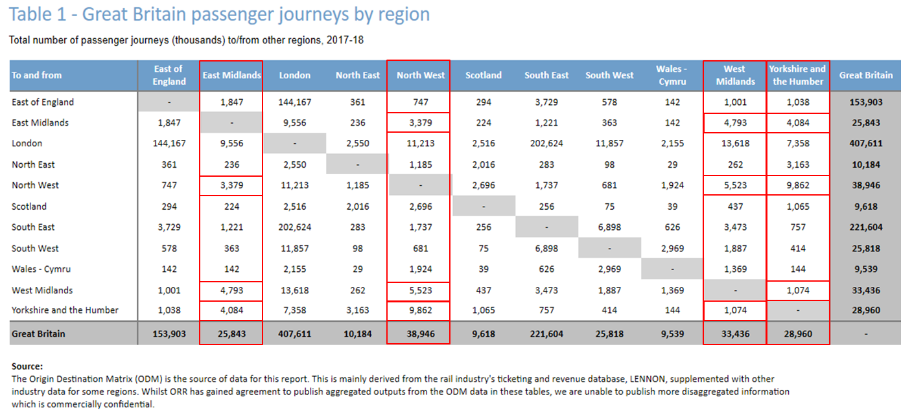

- Even if existing rail usage were forecast to grow at a good rate, e.g. doubling every 10 years or so which would be 7% p.a. compound, it is clear that the core gap to be tackled by inter-regional rail is to be strongly competitive with car to attract more, larger flows to rail which are currently on the road network. This requires a concerted focus on fast inter-regional journey times, with easy hub access to express rail serving the main centres.

- Significant extra inter-urban road capacity has been proposed:-(https://www.gov.uk/government/uploads/system/uploads/attachment_data/file/600275/m160503_the_road_to_growth_Our_strategic_economic_growth_plan.pdf),
There are risks of this being self-defeating as other junctions and urban areas face the consequent traffic growth, with quality-of-life pressures on towns and cities, such as place-making, safety and severance. Higher population densities, public transport and green modes will become necessary solutions in coming decades.

- Rail has to overcome its own shortcomings, by achieving attractive journey times (eg, under 45 minutes or 1 hour, between places only 60 miles apart in a straight line), and accessible hubs with better travel quality and frequency, which will change travel perceptions. Looking ahead several decades, a general step change in rail’s competitiveness is required if rail were targeted to become the preferred inter-urban travel mode across the North and Midlands between main towns and cities.

- As with the main road network, there are constraints to available rail capacity. Additional tracks/signalling and potentially new sections of line are necessary to:
- by-pass bottlenecks and improve area connectivity
- improve train frequency, line capacity and journey times into the heart of city regions
- underpin growth of local economies, with problem-free travel from specified interchanges to jobs and higher education
- enable better local and regional services as well as long distance travel, including quality feeder services to/from long-distance hubs.
- Currently HS2 infrastructure doesn’t do much to grow inter-regional flows between main city and town centres except to/from London and, a lesser extent, Birmingham, Manchester and Leeds. HS2 would be slower than existing West Coast trains between the North West and Scotland.

- There are currently only 7 trains per hour each way proposed on HS2 Phase 2a, between Scotland/NW cities and London, plus some Birmingham-NW service scoping. This is a poor density of use on the new lines, and calls for better utilisation.

- Use of the proposed ‘stand-alone’ HS2 network is also limited within major city regions such as Merseyside and Manchester, because of proposed segregation of HS and regional tracks rather than enabling combined use of extra capacity. This causes area network improvements to be ossified with no new through corridors offered, nor scope to get more benefits by a combination of improved and new services. If one is going to invest billions in rail, much more must be achieved.

- Opportunities to re-specify HS2 exist now, for example with shared use of new trackage on main corridors in the Midlands and North, as exampled below, and breaking through historic network barriers such as cross-Manchester, Liverpool access, and between the West and East Midlands networks.

Crewe as the conduit

- Many opportunities arise through use of Crewe as an existing, principal conduit between the North West and the Midlands. Crewe is the natural hub for many railway operations, as it has been for 150 years. Lines converge from the whole of Wales, the West Midlands, East Midlands and the North West and Scotland.

- Crewe is the opportunity to release local, regional and long-distance rail capacity for future decades, if it is reconfigured with foresight. Network Rail must spend considerable £ millions in the 2020s on Crewe track changes and new signalling, as the existing kit is life-expired, and as more trackage is needed for high speed and associated feeder services. There are already bypass tracks, fast through tracks (which could be faster), many platforms and space for more, and scope to improve rail freight operations which rely on old-style facilities.

- The motto should be, if spending money, spend it wisely. HS2 Phase 2a is intended to use the existing Crewe station, albeit on a constrained basis which doesn’t augur well for capacity for other service improvements. The North West (facing north) and Midlands (facing south) deserve better than that. JRC assessments in 2016-17 show that respecification of how Crewe and its approach tracks are arranged and managed, will enable all the required future capacity for the next half-century.

- If designed carefully, investment in Crewe railways and its junctions will allow much more connectivity and through services. These could be additional HS services making use of spare capacity on the proposed HS2 Phase 2a corridor, or improved classic lines, or a redefined Phase 2b corridor working for the combined benefit of HS and Northern Powerhouse improved services.

- Crewe’s railway role with a revised layout includes creating capacity for inter-regional services between Scotland, the North-West and the West and East Midlands as a new service overlay. With new express chords elsewhere in the network, these could offer environmentally sustainable alternative and competitive journey times, compared to medium- and long-distance car travel, for more journey corridors than HS2 or Northern Powerhouse can achieve on their own.

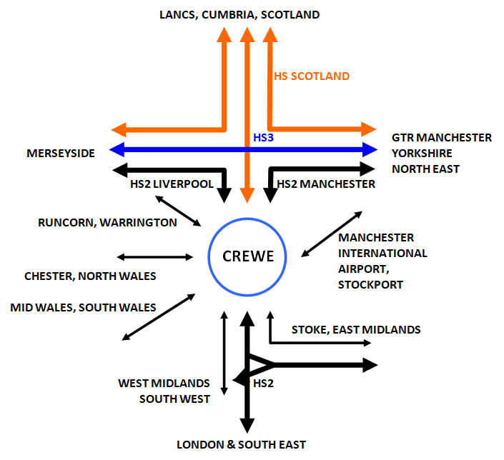

- The scale of inter-regional express services could embrace hourly or twice-hourly between Liverpool/Manchester and the East Midlands in ~60-70-minutes depending on line speed (eg, Manchester-Nottingham, compared to over 105 minutes now, and Liverpool-Leicester in ~70-80 minutes, now 160 minutes). The measurement point is not the current rail demand based on a Trans-Pennine service or changes at Tamworth or Nuneaton, but direct express trains to compete with and improve on car journey times, calling at catchment hubs in the North West and East Midlands.

- It is not assumed that all trains will call at Crewe, but the overall railway corridor capacity through this principal hub must be structured to enable easy through running or as a stopping point, and with scope for further growth, which is discussed in the next section. This applies to management of all other services as well, with flexibility offered.

Better local and regional services, and freight gains

- The strategic reasoning for action has been described above, and centres on connectivity across hub catchments, and area economic growth. The objective is a fully functioning railway interchange, capable of handling more local and regional services and national freight flows, as well as longer distance passenger services. The amount of station platforms, passenger facilities, trackage and approach routes needs to be adequate for decades into the future. Current operational conflicts should be remedied as much as practicable. The underlying questions are: what, and how.

- Basically two actions are needed, allied to the overriding requirement for track and signalling renewal, both of which are already essential in the Crewe area (last renewed around 1985):
- to combine overlapping operational needs from multiple railway services
- to future-proof railway capacity from all directions so that Crewe can support current and future operating requirements including further growth in demand for rail.

- Crewe is a large six-way junction facing NW-SE, with a southern grouping from South Wales and the Borders, the West Coast Main Line from from London and the Midlands, and from the East Midlands and the Potteries, and a northern grouping from Manchester, the NW/Scotland and Liverpool, and from Chester and North Wales. There are bypass lines avoiding the station platforms, for the main corridors.

- Factors to take into account include:
- the passenger railway is becoming much busier: Intercity travel has grown at about 5% per annum on main corridors; local and regional travel has already expanded fast in the past decade, and there is a new Northern franchise agreement and new stakeholder institutions such as Transport for the North and the Northern Powerhouse, focused on growing railway capacity and railway use, to support regeneration and economic growth
- quality inter-urban services such as Trans-Pennine are already attracting more users, with growth up to 7% p.a., with further investment now under way
- Network Rail forecasts a doubling of general passenger use over a 20 year period, from 1.6 billion rail journeys to 3.2 billion
- while some traditional rail freight flows are in decline, eg coal to power stations, West Coast freight train volume is forecast to grow by 50-100% because of intermodal services.

- JRC undertook detailed research in 2016-17 for Crewe Town Council, to assess the current operational volumes and their shortcomings, alongside a range of future rail volumes for different types of services. Options were considered, to change how the station and its tracks should be re-arranged to achieved fewer operational conflicts and increase line and platform capacities affordably.

- A summary of the current situation and proposed improvements is set out below. The detailed operational analysis and recommendations are published on this link:
http://www.jrc.org.uk/PDFs/crew-hub-operability-review-august-2017.docx

- Current capacity requirements: Crewe has complex operational requirements. It also needs adequate operational margins built in to the physical infrastructure and timetable planning. So no more than 75-80% of actual capacity should be utilised here, in order to achieve adequate resilience.

- 2017 timetabling: JRC analysed the weekday May 2017 timetable for this multi-way junction, and assessed train movements in terms of their impact on dwell time and junction conflicts, for the 2AM to Noon period. A summary is provided of total scheduled train use, average intervals between trains, and the proportion of trains incurring less than average ‘free’ time between slots. The latter includes the total time occupied from approach to the Crewe area to the exit from this area.

- Future basis for operational changes: The JRC analysis shows that the worst train operating conflict which currently arises is caused by the Manchester-Marches-Wales trains (crossing all LNW main lines in both directions). Some other flows also limit slot capacity. However, whether a potential slot is actively lost at present is immaterial, as it is the future potential capacity which matters here. The general impacts of HS2’s different Phases are noted, along with their different timescales, and the likely emergence of more frequent commuter and regional Hub services as the Crewe Hub increases in economic importance requiring better accessibility and connectivity. The redesign of Crewe will be required to accommodate all these factors. HS2 Phase 2a is the main driver for substantial change in the Crewe area.

- Choices for change – existing train operations: The main opportunity is to segregate the Manchester-Marches-Wales service, by grade-separating it though use of the low-level Manchester and Salop Independent Lines with a new platform located there.

- Choices for change – HS2 Phases 1 and 2a: In itself, HS2 Phase 1 does not cause many fundamentally new service patterns, although train timings would change. The bigger area changes arise with Phase 2a where high speed tracks reach to within a mile or so of Crewe. However, it is expected that major works would need to be underway in this pre-Phase 1 period, in order to be ready for Phase 2a operations. It is possible that some pre-Phase 2b works might also be desirable, to minimise the impact of multiple work phases and because access costs could rise after Phases 1 and 2a as greater passenger and train volumes (both HS and classic) could require additional compensation.
- Crewe requires the best possible HS services to maximise its accessibility and scope for economic growth throughout a 25 mile Hub catchment.
- Raising the basic HS service level which calls at Crewe from two to four trains per hour would make a fundamental difference to the scope for Hub development (this is discussed in JRC’s Crewe Accessibility paper).
- It already appears that HS2 Phase 2a train speeds will bring Crewe within London commuting times.
- A range of opportunities for improved Northern commuter and regional Hub services is also set out.
- It is important for HS2 changes not to deny improvements to other area services, considered desirable as a consequence of area economic growth and ensuring that Hub benefits are distributed throughout the accessible catchment.
- Other regional and inter-regional priorities also merit consideration at this stage, as works might require incorporation at this stage, for example how better connectivity can be achieved between HS2 and HS3, and how aspirations such as Liverpool’s ‘20-mile’ campaign could be addressed affordably.

- Choices for change – HS2 Phase 2b: HS tracks continue in this Phase past Crewe to Manchester Piccadilly and towards Wigan to rejoin the LNW North main line. New opportunities might arise with London-Edinburgh services via Crewe, a new Crewe link onto HS2 northwards, and through running between the Midlands and the Northern Powerhouse HS3 via HS2. HS2 Phase 2b already envisages new inter-regional HS expresses between Manchester and Birmingham. There is scope based on better connectivity and several new direct HS spurs, for a greater range of HS expresses joining up the main city regions, across the Midlands Engine and the Northern Powerhouse. Options are specified and assessed. Potential journey time savings from such a network are mostly an hour or much more, comparing 2017 and future HS2/3 timings. This could achieve stronger regional economic impacts than a mainly London-focused HS service pattern.

- Essentials and Desirables – works for Crewe capacity and expansion:
- The Essentials are accommodation for HS2, particularly for Phase 2a and 2b requirements, and allowance for a wide range of service changes across the Midlands Engine and Northern Powerhouse, and for additional regional catchment and connectivity services.
- The Desirables are flexibility of London-NW/Scotland service patterns, a higher proportion of HS trains to call at Crewe, and addressing Manchester-Crewe line capacities in a way which supports improved commuter and regional Hub services as well as HS operations. Use of the Independent Lines by Manchester-Wales trains has already been identified in the report.

- Improvement to station facilities is also a pre-requisite. This is foreseen as different and raised bridge crossings of the railway to minimise local traffic congestion and improve road access for the Hub, better arrangements for passenger handling and public transport and green modes’ interchange, and internal reconstruction of pedestrian routes to enable a better environment with more capacity to handle intensive Hub volumes of passenger flows.

- Emerging requirements for track and platform capacities: JRC has undertaken two further train volume analyses – of potential individual passenger services post-HS2, allocated by group of platforms or through tracks within Crewe, and then with the possibility of combining those services to minimise track slot requirements within each operational group.

- Options are also considered, of combining HS2 train calls at existing (or modified) platform groups, or creating a separate HS2 platform group. These analyses show that it is most space efficient, and operable, to use the existing/modified platform groups where possible. This conclusion follows previous consideration of HS2 trains calling at Crewe to have their own platform group, possibly on the ‘Independent’ lines.

- There is an explicit requirement for pre-sorting of services into platform groups, and grade-separation [probably in the Basford area] of the distant HS2 Phase 2a junctions to allow trains to run to/from the different platform groups with limited junction conflict (pathing would be at-grade at the junctions close to the platforms).
- The Westside platform group would generally benefit from having a fourth through platform for express trains calling, with a fully expanded HS and classic Intercity and inter-regional service pattern, and with additional commuter and regional Hub services.
- The Eastside platform group appears capable of handling foreseen train volumes, providing that commuter and regional Hub services are joined together across the two existing through platforms, and then serve further destinations, rather than terminating at Crewe. An additional platform might be required, if more trains terminated.

- The non-stop track requirements depends on which would be more cost-efficient as a whole-life basis – surface tracks allowing high speed passing trains, with the possible requirement for a ‘virtual tunnel’ through the station area, and the two halves of the station having no track connections across, or to adopt the HS2 Ltd's scheme for a deep tunnel under Crewe. The latter might reduce space requirements and ‘knock on’ surface works, and also minimise access costs for large-scale local works.

- Finally, works to enable wider benefits are restated as worth reviewing, beyond the immediate vicinity of Crewe station. These are:
- HS2/’classic’ lines junction, north of Crewe and south of Winsford, to allow HS2 North trains to access Crewe station with better scope for HS services to call, and/or run through Crewe during tunnel maintenance works.
- Works to expand capacity on the Crewe-Sandbach section of the Manchester Line.
- Potential requirement for re-doubling of the Stoke-on-Trent route between North Stafford and Barthomley Junctions.
- Scope to review the HS2 Phase 2b and HS3 infrastructure plans, for example in the North West, to create HS2/3 through running capabilities and help create more integrated, inter-regional HS services between Midlands Engine city regions and the Northern Powerhouse city regions.
- This would include the potential for links to the Liverpool-Chat Moss-Manchester line, and onto the Midland Main Line for direct services to Nottingham and Leicester city regions.

- A table below illustrates the potential for future train slot requirements in the Crewe area, within the track layouts described above.
Analysis of future Crewe train volumes – anticipated passenger train slot volume

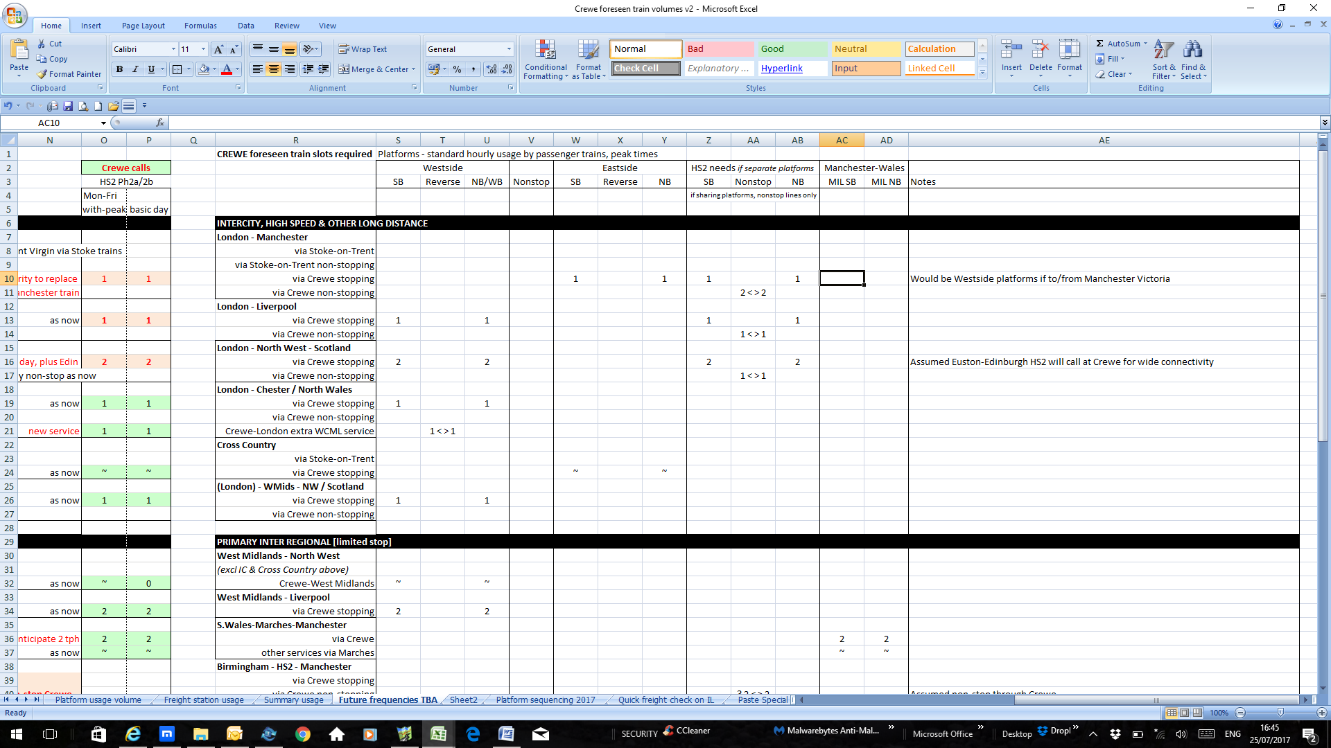
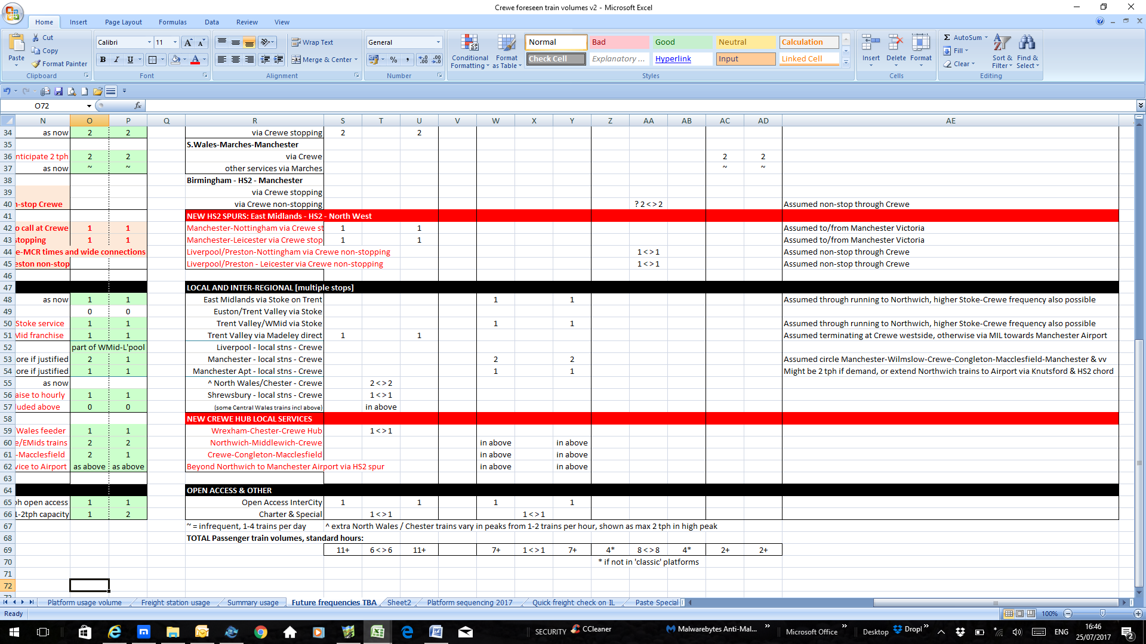

Annex with HS2 Review terms of reference

Link to Commons’ statement by Transport Secretary Grant Shapps: https://www.gov.uk/government/speeches/hs2-update-3-september-2019

Link to HS2 Chairman assessment report:
https://www.gov.uk/government/publications/hs2-ltd-chairmans-stocktake-august-2019

Terms of reference for the independent review of HS2
Published 21 August 2019

Contents
- Purpose
- Review team and support
- Reporting and publication
- Timing

Purpose
The Prime Minister has stated his wish to review “whether and how we proceed” with HS2 ahead of the ‘Notice to Proceed’ decision for Phase 1 (London-West Midlands) due by the end of 2019. The review will assemble and test all the existing evidence in order to allow the Prime Minister, the Secretary of State for Transport and the government to make properly-informed decisions on the future of Phases 1 and 2 of the project, including the estimated cost and schedule position.
For the whole HS2 project, the review should rigorously examine and state its view on:
- whether HS2 Ltd is in a position to deliver the project effectively, taking account of its performance to date and any other relevant information
- the full range of benefits from the project, including but not limited to:
- capacity changes both for services to cities and towns on HS2 and which will not be on HS2
- connectivity
- economic transformation including whether the scheme will promote inclusive growth and regional rebalancing
- environmental benefits, in particular for carbon reduction in line with net zero commitments
- the risk of delivery of these and other benefits, and whether there are alternative strategic transport schemes which could achieve comparable benefits in similar timescales
- the full range of costs of the project, including but not limited to:
- whether HS2 Ltd’s latest estimates of costs and schedule are realistic and are comparable to other UK infrastructure
- why any cost estimates or schedules have changed since the most recent previous baselines
- whether there are opportunities for efficiencies
- the cost of disruption to rail users during construction
- whether there are trade-offs between cost and schedule; and whether there are opportunities for additional commercial returns for the taxpayer through, for example, developments around stations, to offset costs
- what proceeding with Phase 1 means in terms of overall affordability, and what this means in terms of what would be required to deliver the project within the current funding envelope for the project as a whole
- for the project as a whole, how much realistic potential there is for cost reductions in the scheme as currently planned through changes to its scope, planned phasing or specification, including but not limited to:
- reductions in speed
- making Old Oak Common the London terminus, at least for a period
- building only Phase 1
- combining Phases 1 and 2a
- different choices or phasing of Phase 2b, taking account of the interfaces with Northern Powerhouse Rail
- the direct cost of reprioritising, cancelling or de-scoping the project, including but not limited to: contractual penalties; the risk of legal action; sunk costs; remediation costs; supply chain impact; and an estimate of how much of the money already spent, for instance on the purchase of land and property, could be recouped
- whether and how the project could be reprioritised; in particular, whether and, if so how, Northern Powerhouse Rail (NPR) (including the common sections with HS2 Phase 2b) could be prioritised over delivering the southern sections of HS2
- whether any improvements would benefit the integration of HS2, NPR and other rail projects in the north of England or Midlands
- any lessons from the project for other major projects

Review team and support
The review will be chaired by Doug Oakervee. The deputy chair will be Lord Berkeley. There will also be a panel consisting of Michele Dix, Stephen Glaister, Patrick Harley, Sir Peter Hendy, Andrew Sentance, Andy Street, John Cridland and Tony Travers. Each will focus on a specific area of interest; they will feed in to and be consulted on the report’s conclusions, without having a right of veto in the event that consensus cannot be reached.
Support will be provided by the Department for Transport. Sufficient support will be needed to allow a searching and rigorous review in a relatively short time. The review team will be provided with any papers and persons they request. Undertakings of confidentiality will be entered into with the Chair, Deputy Chair, panel, and others as necessary.
Reporting and publication
The review will report to the Secretary of State for Transport with oversight from the Prime Minister and the Chancellor of the Exchequer. It should produce a written report suitable for publication.
Timing
The review should submit its final report in autumn 2019.

